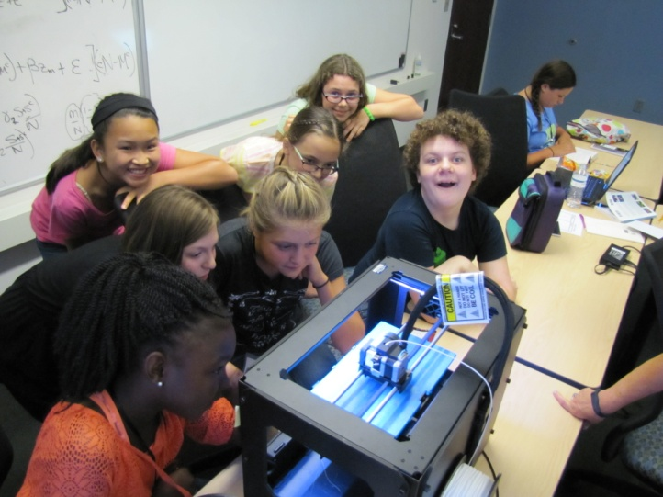
3-D Printing Models of Cell Organelles and Flowers
This hands-on module features active learning using 3-D printing technology to teach middle school students about physical scientific models and cell organelles. This activity has already proven a success at NIMBioS’ “Adventures in STEM Camp” for middle school girls. Access to 3D printing has been a growing trend in K-12 schools. In this curriculum module, aligned with Next Generation Science Standards, students learn about physical models and how they are used in science, then design and print their own representations of different cell organelles or flowers. This activity follows the 5E instructional model.
Preparations and Materials Needed:
- 3-D Printer and plastic
- Computers with internet connectivity and a browser (1 per pair of students)
- Obtain parental consent, or notify parents of activity for the creation of free student Tinkercad accounts. Review Tinkercad privacy policy for guidance.
- Science & Engineering notebooks (or scrap paper for designs)
- Queued videos
- Examples of 3-D printed models and misprints
- For cell organelles – one page printouts of drawings of cell organelles with short explanations of the functions of the organelle. One per pair of students.
- For flower models – field guides to flowers and/or actual flowers, such as flowers collected from the yard or grocery store. Composite flowers such as daisies work especially well, but other options are just fine to show biodiversity.
Engage: Introduce students to the idea that they will be learning about 3-D printing in this activity and that they will be printing either a model of a cell organelle or a flower (teacher choice). Begin with a discussion of models, what they are and how scientists use them.
Show students examples of scientific physical models. We pass around a 3-D printed enlarged mouse skull, a human heart, and a bacteriophage. Ask students to identify the items and explain that they are all physical models created and printed by scientists to help them better understand or communicate to others about something they are studying. Think-Pair-Share: Ask the students to think of another example of a model they have used in the science classroom, including ones that are not 3-D, and jot this down in their science notebook. Ask them to write: How are these models similar to what they are supposed to represent? How do they differ? Why might a scientist want to make a physical model? Have students share what they discussed with the class.
Explore: Provide students with the opportunity to learn more about 3-D printing technology. We use this video which features the 3-D printer we use. Then show students the printer and print a small test print object. Allow students to watch the printing process.
Note: Since NIMBioS does this activity for an event encouraging girls in STEM and particularly in life science, I also like to show this video to introduce students to some of the exciting applications of 3-D printing. Video of Real-World Applications of 3-D printing to biology – Prosthetic Hand for Girl (https://www.youtube.com/watch?v=KK25aLLhDk0).
Explain that students will be designing a 3-D printed model, and since this is an activity that integrates technology and engineering, students will need to apply the engineering design cycle while they work. Review the engineering design cycle if necessary.
The first design criterion is that students will use the 3-D software drawing tool Tinkercad. Help students to set up one account per pair of students on each computer. Then, allow students to work in pairs on tutorials, switching off partners for each tutorial and helping each other. Once all groups complete the die tutorial (allow faster groups to progress to other tutorials), explain that it’s time to start designing models, but a little more explanation is needed, first.
Explain: Bring the class back together for more explanation of criteria and constraints.
Discuss with students more criteria and constraints they will need to follow for their models. Share recourses with students to help them in their model design. For cell organelles, distribute drawings of cell organelles with short descriptions of their functions. For flowers, distribute field guides to flowers, or actual flowers, for students to refer to. It is helpful to have multiple images, so that students can notice how different model depictions emphasize different features, and the pros and cons of this.
Students will also need to consider how the 3-D printer works in order to be successful in their designs. Explain the X, Y and Z axis of printing, and how students need to consider that each horizontal cross-section is printed from the base to the top, and so must avoid having thing print in unsupported space. Show “misprints” or other failed prints from previous printings that can show other ways the printing process might go wrong. Let the students know the size limitations (we suggest no larger than 3 inches in any direction) and time limitations of how much design time they will have.
Students first sketch (in science notebooks, or on paper) the model they will create in Tinkercad software. Students can do this individually, and then combine the best features of their ideas with their partners on one final design, to be approved by the teacher before proceeding. When student partners indicate that they have finished their sketch and raise a hand, the teacher can come by to discuss with the students and provide guidance on how to implement their design in the software.
Elaborate: Students draw their models in Tinkercad. They troubleshoot design issues with their partner, teacher, or other groups if the teacher notices that one group might benefit from design techniques of another.
Models are saved as printable files on a teacher’s USB key when students are done. Students that finish early might start printing their models, or may continue to design another item in Tinkercad.
For all models to be printed, it’s likely the teacher will have to continue the printing beyond the class period. One could have the printer going in the background during other classes, with the conclusion of this activity taking place after all the printing is complete. If models don’t print well, this is perfectly ok, as the students should get the opportunity to evaluate what went wrong in the last phase of this activity.
Evaluate: Students receive their printed models, evaluate their success and compare their designed solutions to other students’.
For cell organelle activity only: Have the class assemble the organelles into a “cell”. Have each student pair present their organelle to the class, explain how it functions in the cell, and then add the organelle to an overall class model, such as a rounded piece of felt or cardboard representing the cell.
Model Design Fair: Ask students to take a piece of paper and fold it in half. On one half, write “What worked” and on the other “What could be improved/Advice”. Ask the partners to fill in 1-2 items under each heading. Then, set the models up in a “Model Fair” at stations throughout the room and allow students to rotate around the room to feedback to each other.
To conclude, students synthesize the class feedback into a summary paragraph in their science notebooks where they include a sketch or photo of their model, explain what their model represents, the limitations of their model, and justifying their model. Then, they should conclude with advice for future students using 3-D printing for their models.
If time permits, the teacher might allow the students to redesign and reprint their models.
Relevant Middle School Standards
- Next Generation Science Standards (NGSS) Middle School Engineering Design
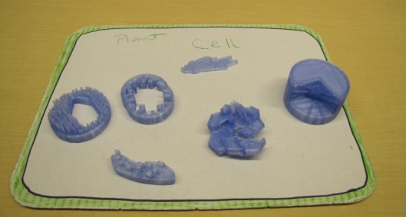
- NGSS MS-LS1-2. Develop and use a model to describe the function of a cell as a whole and ways parts of cells contribute to the function.
Developed by K. Sturner, 2016, NIMBioS, www.nimbios.org

